# **CUSTOMER RELATIONSHIP MANAGEMENT SYSTEM**

A PROJECT REPORT

#### Submitted by

ANUSHTIKA S U [RA2211026010400]

KISHORE KHANNAN [RA2211026010409]

KEERTHIVASAN R [RA2211026010424]

#### Under the Guidance of

## Dr. ANTONY SOPHIA N

Assistant Professor

Department of Computational Intelligence

### *in partial fulfillment of the requirements* *for the degree of*

## BACHELOR OF TECHNOLOGY

## in

## COMPUTER SCIENCE ENGINEERING

## with specialization in ARTIFICIAL INTELLIGENCE AND MACHINE LEARNING



## DEPARTMENT OF COMPUTATIONAL INTELLIGENCE COLLEGE OF ENGINEERING AND TECHNOLOGY

SRM INSTITUTE OF SCIENCE AND TECHNOLOGY

## KATTANKULATHUR- 603 203

MAY 2025

Department of Computational Intelligence

##### SRM Institute of Science & Technology

##### Own Work Declaration Form

This sheet must be filled in (each box ticked to show that the condition has been met). It must be signed and dated along with your student registration number and included with all assignments you submit – work will not be marked unless this is done.

To be completed by the student for all assessments

##### Degree/ Course : Software Engineering and Project Management

**Student Name : Anushtika S U, Kishore Khannan, Keerthivasan R**

##### Registration Number : RA2211026010400, RA2211026010409, RA2211026010424

**Title of Work : Customer Relationship Management System**

I / We hereby certify that this assessment compiles with the University’s Rules and Regulations relating to Academic misconduct and plagiarism**, as listed in the University Website, Regulations, and the Education Committee guidelines.

I / We confirm that all the work contained in this assessment is my / our own except where indicated, and that I / We have met the following conditions:

* Clearly referenced / listed all sources as appropriate
* Referenced and put in inverted commas all quoted text (from books, web, etc)
* Given the sources of all pictures, data etc. that are not my own
* Not made any use of the report(s) or essay(s) of any other student(s) either past or present
* Acknowledged in appropriate places any help that I have received from others (e.g. fellow students, technicians, statisticians, external sources)
* Compiled with any other plagiarism criteria specified in the Course handbook / University website

I understand that any false claim for this work will be penalized in accordance with the University policies and regulations.

| **DECLARATION:** |
| --- |
| I am aware of and understand the University’s policy on Academic misconduct and plagiarism and I certify that this assessment is my / our own work, except where indicated by referring, and that I have followed the good academic practices noted above. |
| RA2211026010400 Anushtika S U  RA2211026010409 Kishore Khannan  RA2211026010424 Keerthivasan R |

# Logo

# SRM INSTITUTE OF SCIENCE AND TECHNOLOGY KATTANKULATHUR – 603 203

## BONAFIDE CERTIFICATE

Certified that 18CSP107L - Minor Project [18CSP108L- Internship] report titled “**CUSTOMER RELATIONSHIP MANAGEMENT SYSTEM**” is the bonafide work of “**ANUSHTIKA S U [RA2211026010400], KISHORE KHANNAN [RA2211026010409], KEERTHIVASAN R [RA2211026010424]”** who carried out the project work under my supervision. Certified further, that to the best of my knowledge the work reported herein does not form any other project report or dissertation on the basis of which a degree or award was conferred on an earlier occasion on this or any other candidate.

**SIGNATURE SIGNATURE**

##### 

##### Dr. ANTONY SOPHIA N DR. R. ANNIE UTHRA

| **SUPERVISOR**  ASSISTANT PROFESSOR  DEPARTMENT OF  COMPUTATIONAL  INTELLIGENCE |  | **PROFESSOR &HEAD**  DEPARTMENT OF  COMPUTATIONAL INTELLIGENCE |
| --- | --- | --- |

**ACKNOWLEDGEMENTS**

We express our humble gratitude to **Dr. C. Muthamizhchelvan**, Vice-Chancellor, SRM Institute of Science and Technology, for the facilities extended for the project work and his continued support.

We extend our sincere thanks to **Dr. Leenus Jesu Martin M,** Dean-CET, SRM Institute of Science and Technology, for his invaluable support.

We wish to thank **Dr. Revathi Venkataraman**, Professor and Chairperson, School of Computing, SRM Institute of Science and Technology, for her support throughout the project work.

We encompass our sincere thanks to, **Dr. M. Pushpalatha**, Professor and Associate Chairperson - CS, School of Computing and **Dr. Lakshmi,** Professor and Associate Chairperson -AI, School of Computing, SRM Institute of Science and Technology, for their invaluable support.

We are incredibly grateful to our Head of the Department, **Dr. R. Annie Uthra**, Professor and Head, Department of Computational Intelligence, SRM Institute of Science and Technology, for her suggestions and encouragement at all the stages of the project work.

We want to convey our thanks to our Project Coordinators, Panel Head, and Panel Members Department of Computational Intelligence, SRM Institute of Science and Technology, for their inputs during the project reviews and support.

We register our immeasurable thanks to our Faculty Advisor, **Dr. M. Salomi Samsudeen**, Department of Computational Intelligence, SRM Institute of Science and Technology, for leading and helping us to complete our course.

Our inexpressible respect and thanks to our guide, **Dr. Antony Sophia N**, Department of Computational Intelligence, SRM Institute of Science and Technology, for providing us with an opportunity to pursue our project under his / her mentorship. He / She provided us with the freedom and support to explore the research topics of our interest. His / Her passion for solving problems and making a difference in the world has always been inspiring.

We sincerely thank all the staff members of the Department of Computational Intelligence, School of Computing, S.R.M. Institute of Science and Technology, for their help during our project. Finally, we would like to thank our parents, family members, and friends for their unconditional love, constant support and encouragement.

Authors

### **ABSTRACT**

This project involves the development of a cloud-native Customer Relationship Management system designed to streamline the entire customer lifecycle. The application offers a suite of core CRM functionalities including centralized management of contacts and accounts, lead and opportunity tracking, workflow automation, omnichannel communication support, and real-time data analytics and reporting. Built with a focus on scalability, modularity, and user experience, the system empowers organizations to improve customer engagement, boost productivity, and support data-informed decision-making. The platform’s cloud-native architecture ensures high availability, seamless updates, and easy integration with third-party services, making it adaptable to evolving business needs. Moreover, the project aligns with the United Nations Sustainable Development Goals, particularly SDG 8 (Decent Work and Economic Growth) and SDG 9 (Industry, Innovation, and Infrastructure). It promotes innovation and digital transformation by enabling automated, sustainable, and efficient business operations. Through resilient infrastructure and intelligent software design, the CRM system supports organizations in building long-term customer relationships while contributing to economic and technological advancement.

**TABLE OF CONTENTS**

**ABSTRACT iv**

**TABLE OF CONTENTS v**

**LIST OF FIGURES vi**

**LIST OF TABLES vii**

**ABBREVIATIONS viii**

**CHAPTER NO. TITLE PAGE NO.**

**1 INTRODUCTION 1**

1.1 Introduction to Project 2

1.2 Motivation 3

1.3 Sustainable Development Goal of the Project 4 1.4 Product Vision Statement 5

1.5 Product Goal 6

1.6 Product Backlog (Key User Stories with Desired Outcomes) 7

1.7 Product Release Plan 8

**2 SPRINT PLANNING AND EXECUTION 9**

**2.1 Sprint 1 10** 2.1.1 Sprint Goal with User Stories of Sprint 1 11

2.1.2 Functional Document 12

2.1.3 Architecture Document 13

2.1.4 UI Design 14

2.1.5 Functional Test Cases 15

2.1.6 Daily Call Progress 16

2.1.7 Committed vs Completed User Stories 17

2.1.8 Sprint Retrospective 18

**2.2 Sprint 2 19**

2.2.1 Sprint Goal with User Stories of Sprint 2 20

2.2.2 Functional Document 21

2.2.3 Architecture Document 22

2.2.4 UI Design 23

2.2.5 Functional Test Cases 24

2.2.6 Daily Call Progress 25

2.2.7 Committed vs Completed User Stories 26

2.2.8 Sprint Retrospective 27

**3.** **RESULTS AND DISCUSSIONS 28**

3.1 Project Outcomes (Justification of outcomes and how they align 29

with the goals)

3.2 Committed vs Completed User Stories 30

**4 CONCLUSIONS & FUTURE ENHANCEMENT 31**

**APPENDIX 32**

**A. PATENT DISCLOSURE FORM 33**

**B. SAMPLE CODING 34**

**C. PLAGIARISM REPORT 35**

**LIST OF FIGURES**

**CHAPTER NO TITLE PAGE NO.**

1.1 MS Planner Board of CRM Application

1.2 Release plan of CRM Application

2.1 User story for user management

2.2 User story for role based access control

2.3 User story for lead tracking

2.4 User story for lead scoring

2.5 User story for lead tracking

2.6 User story for lead tracking

2.7 CRM System Architecture

2.8 ER Diagram for CRM System

2.9 Use Case Diagram

2.10 Class Diagram

2.11 UI Design of dashboard page

2.12 UI Design of leads page

2.13 UI Design of analytics page

2.14 Committed Vs Completed User Stories sprint 1

2.15 User story for sales performance

2.16 User story for seamless interaction

2.17 User story for third-party integration

2.18 User story for access levels

2.19 CRM System Architecture

2.20 UI Design for Users

2.21 UI Design for Communications

2.22 Committed Vs Completed User Stories sprint 2

3.1 Committed Vs Completed User Stories

**LIST OF TABLES**

**CHAPTER NO TITLE PAGE NO.**

1.1 User Stories of CRM Application

2.1 Detailed User Stories of sprint 1

2.2 Access level Authorization Matrix for sprint 1

2.3 Detailed Functional Test Case sprint 1

2.4 Sprint Retrospective for the Sprint 1

2.5 Detailed User Stories of sprint 2

2.6 Access level Authorization Matrix for sprint 2

2.7 Detailed Functional Test Case sprint 2

2.8 Sprint Retrospective for the Sprint 2

**ABBREVIATIONS**

**CHAPTER 1**

**INTRODUCTION**

**1.1 Introduction to Customer Relationship Management System:**

In the current business environment, effective management of customer relationships is vital to sustaining growth and ensuring competitive advantage. This project focuses on the design and development of a cloud-based Customer Relationship Management (CRM) system intended to centralize and automate critical business functions. The CRM platform aims to streamline sales processes, enhance marketing strategies, and facilitate seamless customer interactions through a unified digital interface. The system offers functionalities such as contact and account management, lead tracking, communication tools, workflow automation, and real-time analytics. By leveraging cloud computing technologies, the CRM system ensures accessibility, scalability, and data-driven decision-making capabilities for businesses of all sizes.

**1.2 Motivation**

The motivation behind this project stems from the increasing demand for intelligent, adaptable, and cost-effective CRM solutions, particularly among small and medium-sized enterprises (SMEs). Many existing CRM tools are either too complex or lack the flexibility to meet dynamic business requirements. This project aims to bridge that gap by providing a user-friendly, cloud-native CRM platform that supports automation, integration, and personalized customer engagement. The overarching goal is to enable organizations to improve customer retention, boost productivity, and make informed strategic decisions based on real-time data analytics.

**1.3 Sustainable Development Goal of the Project**

The CRM platform aligns closely with the United Nations Sustainable Development Goal 8 **SDG 8 – Decent Work and Economic Growth**, which aims to promote inclusive and sustainable economic growth, full and productive employment, and decent work for all. By integrating automation, lead management, and performance tracking into a centralized system, the CRM enhances business efficiency and productivity. It enables sales and support teams to focus on higher-value tasks, thereby increasing job satisfaction, reducing manual workload, and contributing to economic output. Small and medium enterprises (SMEs), in particular, benefit from this digital enablement, as it allows them to scale operations efficiently and compete in larger markets.

Additionally, the project addresses **SDG 9: Industry, Innovation, and Infrastructure**, which emphasizes building resilient infrastructure, fostering innovation, and promoting sustainable industrialization. The CRM system is built on a cloud-native architecture with integrated analytics, mobile accessibility, and secure access controls. This modern infrastructure not only supports real-time decision-making but also ensures that the system can adapt to the evolving technological landscape. By facilitating integration with third-party services and offering scalability, the platform supports digital transformation across industries.

Moreover, the system promotes **technological inclusivity** by offering an intuitive user interface and mobile compatibility, ensuring accessibility for users across devices and varying technical backgrounds. This helps bridge the digital divide and encourages broader adoption of smart business technologies, especially in developing or resource-limited settings.

By addressing these key development goals through practical, technology-driven solutions, the CRM platform fosters innovation, supports economic growth, and contributes to the creation of a more efficient and digitally empowered business ecosystem.

**1.4 Product Vision Statement**

**1.4.1. Audience:**

* Primary Audience: Small and medium-sized enterprises (SMEs), startups, and growing businesses seeking an efficient, scalable solution for managing customer interactions, sales pipelines, and marketing activities.
* Secondary Audience: Business analysts, sales professionals, customer support teams, and administrators responsible for customer data management and operational optimization.

**1.4.2. Needs:**

Primary Needs:

* A centralized platform for managing contacts, leads, and customer communications.
* Automated task management and sales pipeline tracking to reduce manual workload.
* Real-time analytics and reporting for data-driven decision-making.

Secondary Needs:

* Role-based access control for secure and structured user management.
* Seamless mobile accessibility for remote operations.
* Integration capabilities with third-party tools (e.g., email platforms, calendars, ERP systems).

**1.4.3. Products:**

Core Product: A cloud-based Customer Relationship Management (CRM) system that consolidates contact management, lead tracking, communication, task automation, and analytics into a unified platform.

Additional Features:

* Real-time reporting dashboard for business insights.
* Omnichannel communication center (email, chat integration).
* Mobile-responsive interface for anytime, anywhere access.
* API-based integration for third-party services and tools.

**1.4.4. Values:**

Core Values:

* Efficiency: Automating processes to save time and reduce human error.
* Accessibility: Ensuring easy access across devices and platforms.
* Scalability: Supporting businesses as they grow and evolve.

Differentiators:

* Cloud-Native Architecture: Enables real-time access, flexibility, and minimal downtime.
* Integrated Communication Tools: Reduces the need for external platforms by centralizing interactions.
* Data-Driven Insights: Empowers teams with actionable intelligence through analytics.
  1. **Product Goal**

The overarching goal of this Customer Relationship Management (CRM) platform is to revolutionize the way organizations handle and nurture customer relationships by delivering an intelligent, unified, and scalable digital solution. In an era where customer experience directly impacts business success, the platform is designed to streamline operations, enhance engagement, and empower decision-makers with real-time, data-driven insights. It serves as a centralized hub where businesses can efficiently manage contacts, monitor leads and opportunities, automate routine workflows, and generate actionable analytics that support strategic planning and growth. The platform also integrates seamlessly with third-party tools and services, supporting interoperability in dynamic business ecosystems.

One of the platform’s defining objectives is to democratize access to robust CRM functionalities. While enterprise solutions often come with high costs and steep learning curves, this system is built with inclusivity and accessibility in mind. It is tailored to meet the needs of small and medium-sized businesses (SMEs), which frequently lack the resources or technical expertise to adopt traditional CRM systems. The intuitive user interface, mobile accessibility, and modular structure allow businesses to adopt features incrementally, scaling their use of the system as they grow—without disrupting operations or incurring unnecessary complexity.

The CRM also emphasizes data integrity and consistent service delivery. Automated tools help maintain clean, up-to-date records, while built-in validation ensures accuracy in data entry. With robust security protocols and user role management, sensitive customer information is protected, and team collaboration remains structured and efficient.

More than just a tool for tracking sales or storing contact details, the platform is conceived as a strategic asset for building resilient and sustainable business infrastructures. It supports long-term relationship building by providing a comprehensive view of each customer’s journey, enabling personalized engagement strategies and proactive service delivery. By centralizing key data and communications, the platform fosters interdepartmental collaboration and eliminates data silos—improving transparency and alignment across marketing, sales, and support teams.

**1.6 Product Backlog**

Table 1.1 User Stories of CRM Application

| **S.No** | **User Stories of CRM Application** |
| --- | --- |
| #US 1 | As a new user, I want to register and create a secure profile so I can access CRM features tailored to my role. |
| #US 2 | As a sales representative, I want to add and manage customer contact information so I can track interactions effectively. |
| #US 3 | As a sales manager, I want to assign leads to team members and monitor their progress to optimize performance. |
| #US 4 | As a user, I want to view customer history and previous interactions to provide personalized support. |
| #US 5 | As a marketer, I want to schedule and automate email campaigns to engage leads and customers at scale. |
| #US 6 | As a user, I want to receive real-time notifications for lead activity and tasks so I can respond promptly. |
| #US 7 | As a manager, I want access to visual dashboards and reports so I can analyze sales performance and customer engagement. |
| #US 8 | As a user, I want to communicate with customers via email, chat, or phone within the platform for seamless interaction. |
| #US 9 | As a user, I want to integrate CRM data with third-party tools like Google Calendar and email for smoother workflow. |
| #US 10 | As an admin, I want to set user permissions and access levels so I can ensure security and control over data. |
| #US 11 | As a user, I want to access the CRM on mobile devices so I can manage leads and tasks on the go. |

The product backlog of CRM Application was configured using the MS planner Agile Board which is represented in the following Figure 1.1. The Product Backlog consists of the complete user stories of CRM Application

Each user story consist of necessary parameters like MoSCoW prioritization, Functional and non functional parameters, detailed acceptance criteria with linked tasks.

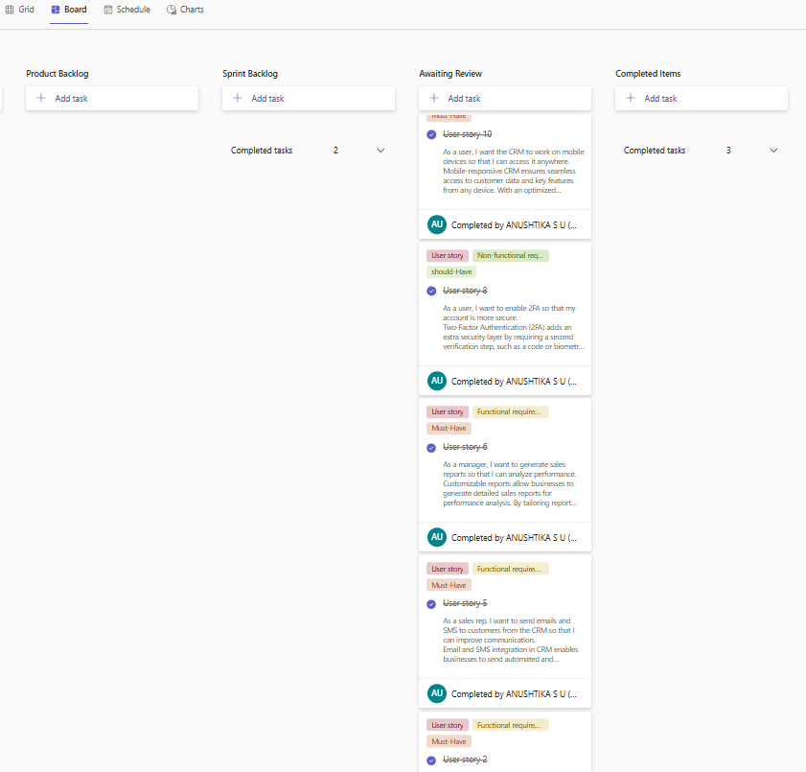Figure 1.1 MS Planner Board of CRM Application

**1.7 Product Release Plan**

The following Figure 1.2 depicts the release plan of the project

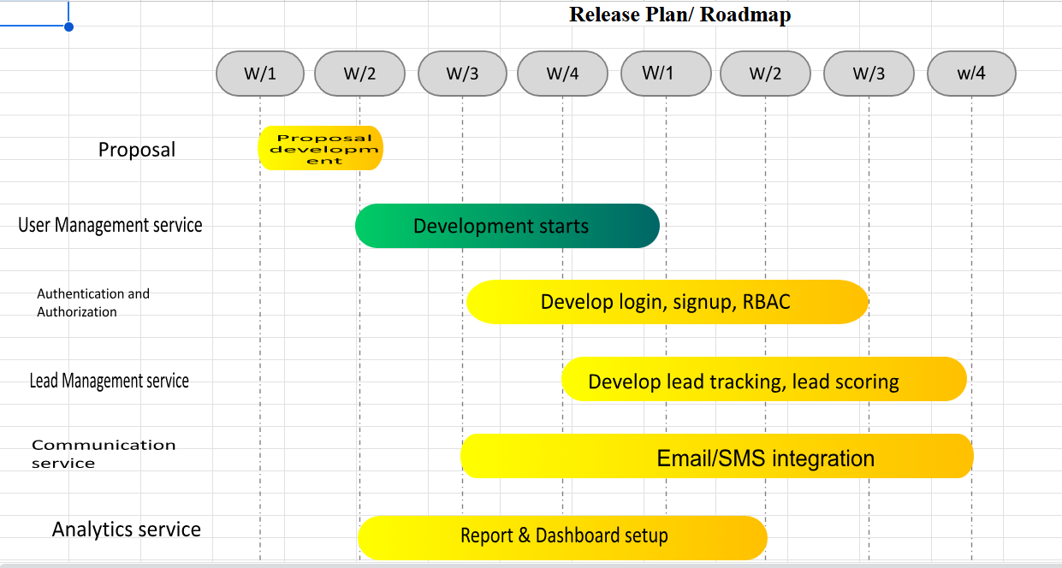

Figure 1.2 Release plan of CRM Application

**CHAPTER 2**

**SPRINT PLANNING AND EXECUTION**

**2.1 Sprint 1**

**2.1.1 Sprint Goal with User Stories of Sprint 1**

In Sprint 1, the goal is to build the core features that allow users to manage their finances securely. This includes implementing user registration and login with secure authentication to protect account access. Users will be able to input income and log expenses, forming the basis for financial tracking. A simple dashboard will display key financial metrics such as total income, expenses, and balance, giving users an immediate overview of their financial status. This sprint lays the groundwork for more advanced features in future iterations.

The following table 2.1 represents the detailed user stories of the sprint 1

**Table 2.1 Detailed User Stories of sprint 1**

| **S.No** | **User Stories of CRM Application** |
| --- | --- |
| #US 1 | As a new user, I want to register and create a secure profile so I can access CRM features tailored to my role. |
| #US 2 | As a sales representative, I want to add and manage customer contact information so I can track interactions effectively. |
| #US 3 | As a sales manager, I want to assign leads to team members and monitor their progress to optimize performance. |
| #US 4 | As a user, I want to view customer history and previous interactions to provide personalized support. |
| #US 5 | As a marketer, I want to schedule and automate email campaigns to engage leads and customers at scale. |
| #US 6 | As a user, I want to receive real-time notifications for lead activity and tasks so I can respond promptly. |

Planner Board representation of user stories are mentioned below figures 2.1,2.2,2.3 and 2.4

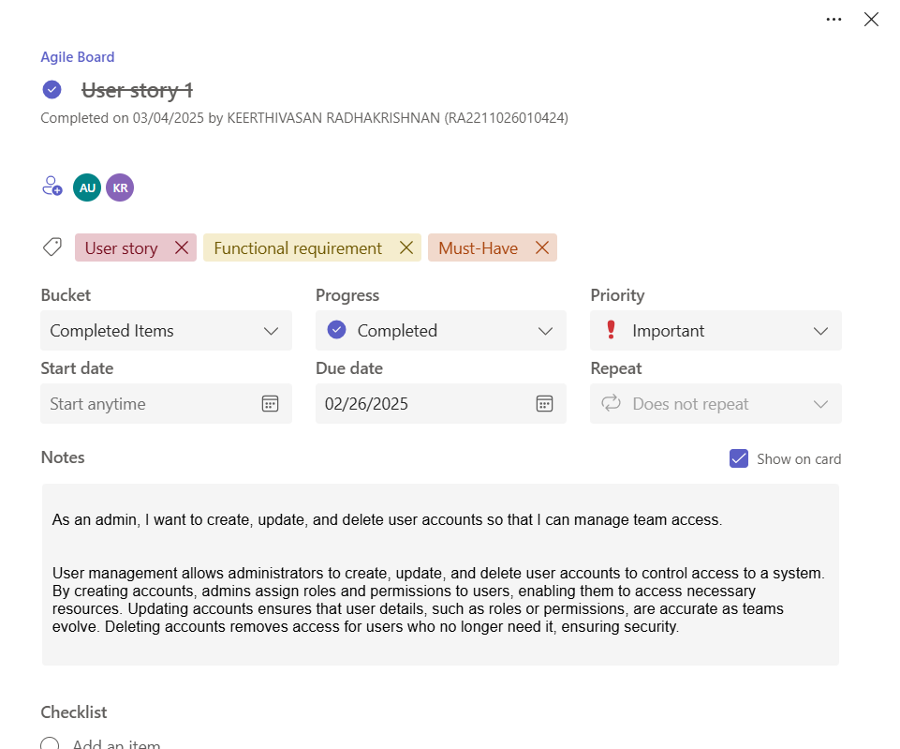

Figure 2.1 User story for user management

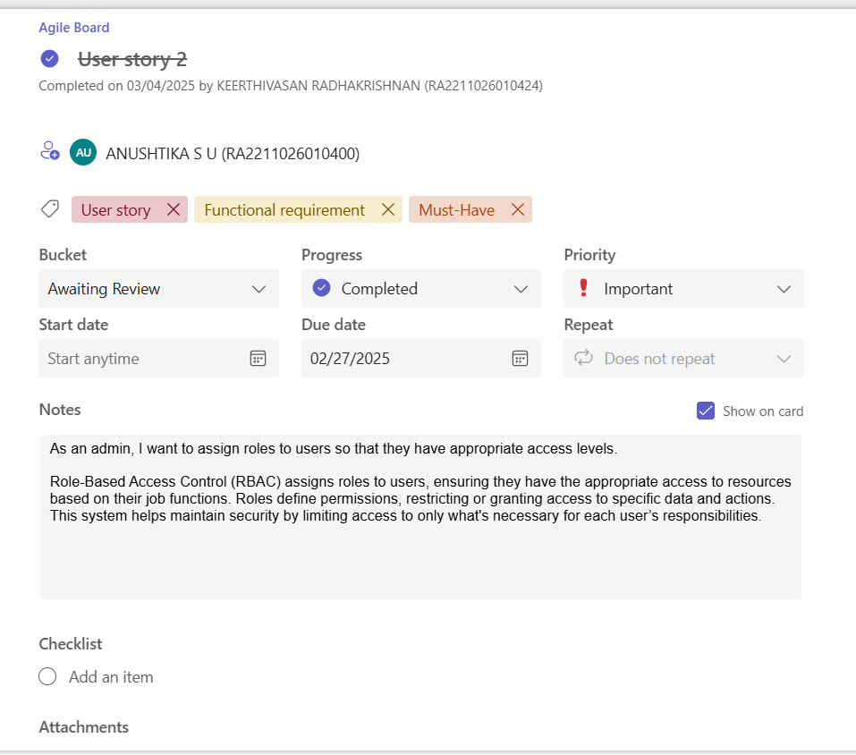

Figure 2.2 User story for role based access control

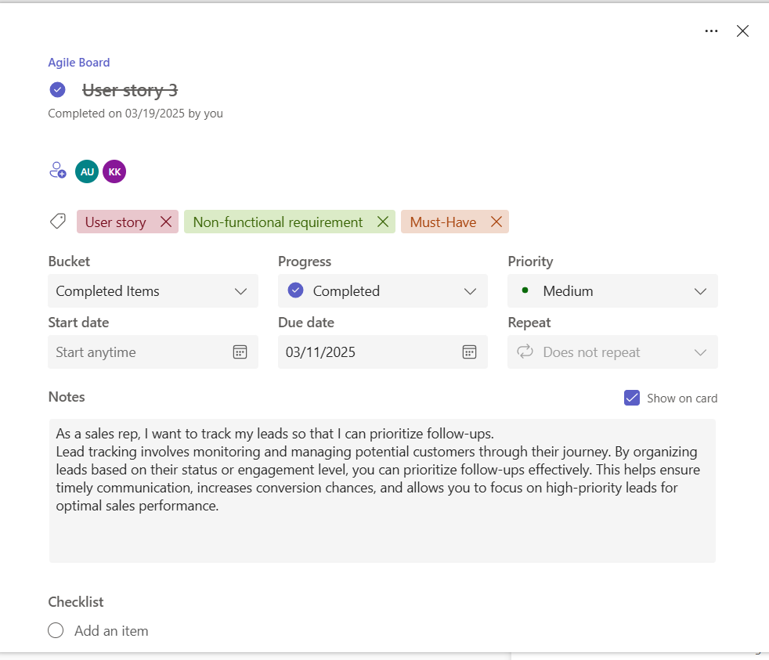

Figure 2.3 User story for lead tracking

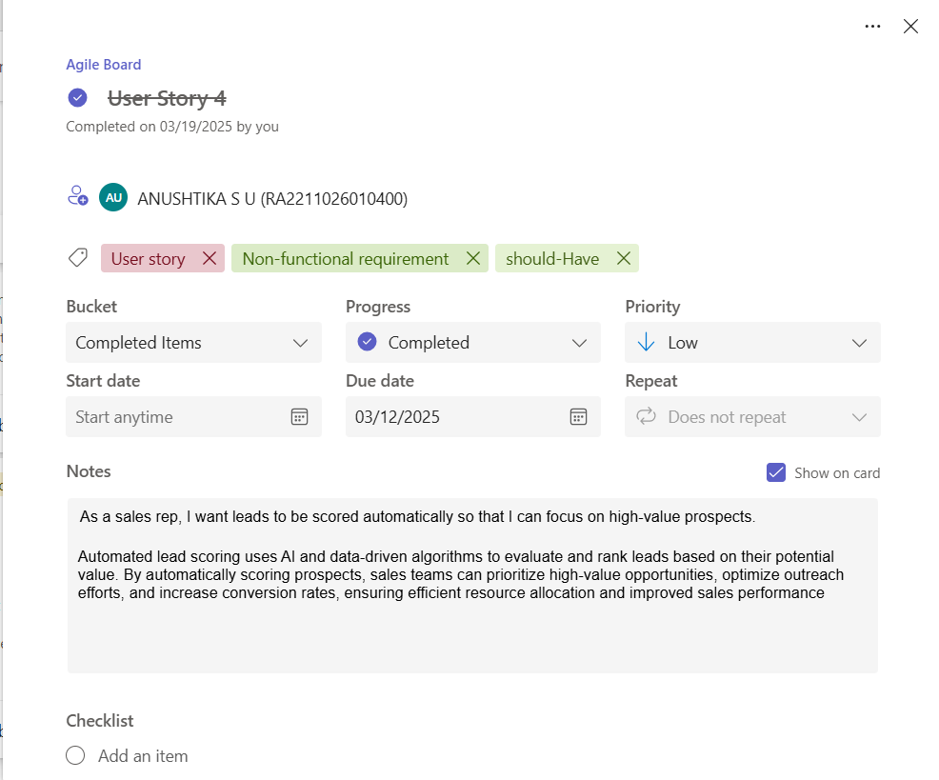

Figure 2.3 User story for lead scoring

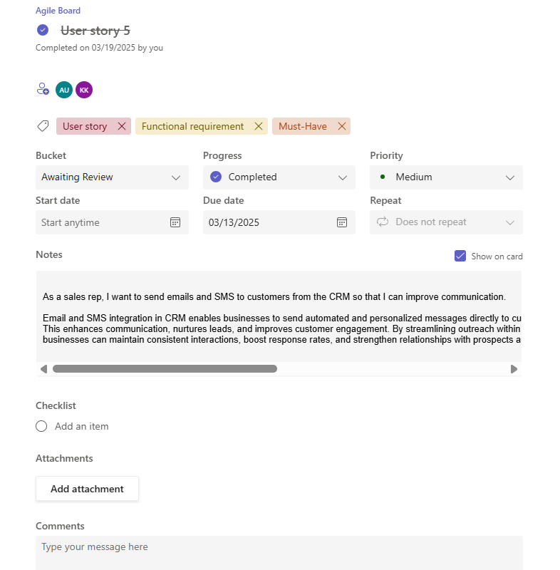

Figure 2.3 User story for lead tracking

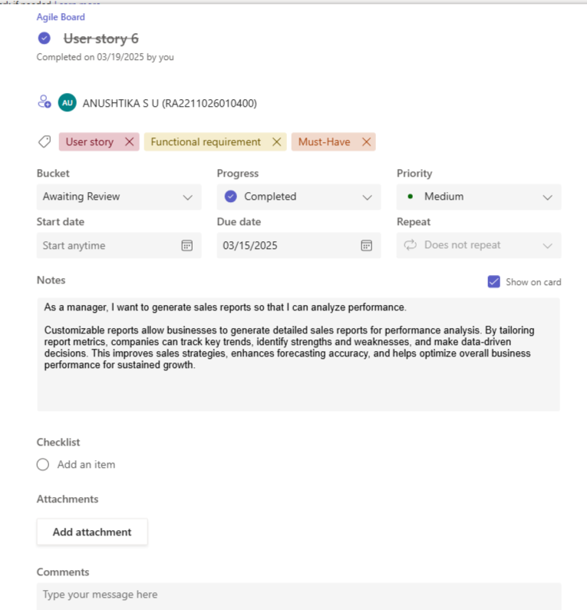

Figure 2.3 User story for lead tracking

**2.1.2 Functional Document**

**2.1.2.1. Introduction**

The Customer Relationship Management (CRM) system is designed to streamline and enhance the way businesses interact with their customers. This document outlines the functional requirements, goals, and features of the CRM project. The system will enable businesses to manage customer data, track interactions, and improve customer satisfaction through efficient communication and data-driven insights

**2.1.2.2. Product Goal**

The primary goal of the CRM system is to:

* Centralize customer data for easy access and management.
* Improve customer engagement through personalized interactions.
* Automate repetitive tasks to increase operational efficiency.
* Provide actionable insights through analytics and reporting.
* Enhance customer retention and satisfaction by tracking and resolving issues effectively.

**2.1.2.3. Demography (Users, Location)**

### Users:

* Sales Teams: To manage leads, track deals, and close sales.
* Customer Support Teams: To handle customer queries, complaints, and feedback.
* Marketing Teams: To run campaigns, track customer behavior, and analyze trends.
* Managers/Executives: To monitor performance metrics and make data-driven decisions.

### Location:

The CRM system will be accessible globally, with support for multiple languages and regional customization. It will cater to businesses of all sizes, from small enterprises to large corporations, across industries such as retail, healthcare, finance, and technology

**2.1.2.4. Business Processes**

The CRM system will support the following business processes:

* Lead Management: Capturing, tracking, and converting leads into customers.
* Customer Data Management: Storing and organizing customer information in a centralized database.
* Interaction Tracking: Logging all customer interactions (calls, emails, meetings, etc.).
* Sales Pipeline Management: Visualizing and managing the sales process from lead to closure.
* Customer Support: Managing tickets, resolving issues, and maintaining customer satisfaction.
* Reporting and Analytics: Generating insights on customer behavior, sales performance, and team productivity.

**2.1.2.5. Features**

### **Feature 1: Customer Data Management**

Description:  
A centralized database to store and manage customer information, including contact details, interaction history, purchase records, and preferences.

User Story:  
As a sales representative, I want to access a customer’s complete interaction history so that I can provide personalized service and close deals faster.

### **Feature 2: Lead Management**

Description:  
A system to capture, track, and prioritize leads based on predefined criteria such as source, interest level, and potential value.

User Story:  
As a marketing manager, I want to track the status of leads generated from campaigns so that I can measure the effectiveness of my efforts.

**Feature 3: Sales Pipeline Management**

Description:  
A visual representation of the sales process, allowing users to track deals through various stages (e.g., prospecting, negotiation, closure).

User Story:  
As a sales manager, I want to view the sales pipeline to identify bottlenecks and ensure timely follow-ups.

**Feature 4: Customer Support Ticketing**

Description:  
A ticketing system to log, prioritize, and resolve customer issues efficiently.

User Story:  
As a customer support agent, I want to assign and track support tickets so that I can ensure timely resolution of customer issues.

**Feature 5: Reporting and Analytics**

Description:  
Customizable dashboards and reports to analyze customer behavior, sales performance, and team productivity.

User Story:  
As an executive, I want to view sales performance reports so that I can make informed decisions and allocate resources effectively.

**2.1.2.6. Authorization Matrix**

The CRM system will have role-based access control to ensure data security and privacy:

**Table 2.2 Authorization matrix for sprint 1**

| **Role** | **Access Levels** |
| --- | --- |
| Admin | Full Access (CRUD operations across the system) |
| Sales Rep | Limited Access (View and update own contacts, receive notifications) |
| Sales Manager | Moderate Access (Assign leads, monitor progress, view customer history) |
| Marketer | Moderate Access (Create and schedule campaigns, view interactions) |
| User | Basic Access (View own profile and customer interactions, receive notifications) |

**2.1.2.7. Assumptions**

* Dashboards and reporting modules will be powered by real-time data from the CRM database and use standard visualization libraries (e.g., Chart.js or Power BI).
* Communication channels (email, chat, phone) are assumed to be integrated using secure and scalable third-party APIs like SendGrid, Twilio, or similar.
* Calendar and email integrations (e.g., Google Calendar, Outlook) require users to authenticate using OAuth 2.0 for access to external data.
* Role-based access control (RBAC) will be implemented via an admin dashboard and assumes roles are predefined during system setup.
* Mobile access assumes the CRM uses responsive design or a PWA (Progressive Web App) and users will have stable internet connectivity.
* All users accessing sensitive data or communication logs must be authenticated, and data access is governed by permissions set by the admin.

**2.1.3 Architecture Document**

Key services include:

1. Contact and Lead Management  
    Enables users to store, update, and track customer and lead information, including communication history and interaction logs.
2. Sales and Pipeline Management  
    Helps sales teams manage deals, assign leads, monitor sales stages, and forecast revenue through a visual sales pipeline.
3. Marketing Automation  
    Provides tools to create, schedule, and analyze email campaigns, segment customers, and manage marketing workflows.
4. Customer Support and Interaction Tracking  
    Allows users to log service requests, track customer issues, and view complete customer interaction histories for better support.
5. Analytics and Reporting  
    Delivers real-time insights through dashboards and reports, using visualizations to track performance metrics, user activities, and customer behavior.

**2.1.3.1 System Architecture**

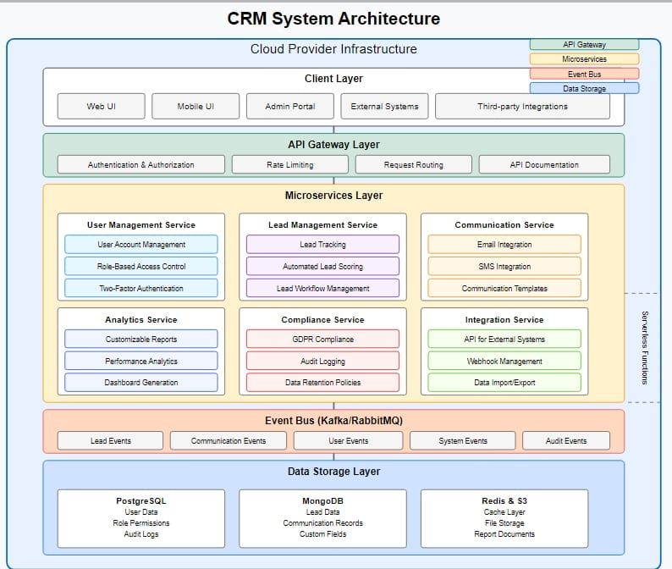

Figure 2.1 CRM System Architecture

**1.1. Microservices**

The CRM system will be implemented using a microservices architecture. This approach is most suitable for the project due to the following reasons:

* Scalability: Individual services can be scaled independently based on demand. For example, the lead scoring service might require more resources during marketing campaigns.
* Maintainability: Each functional area can be developed, tested, and deployed independently, making it easier to manage the codebase.
* Technology flexibility: Different services can use different technologies as needed for their specific requirements.
* Fault isolation: Issues in one service (e.g., email integration) won't affect other parts of the system.

The following microservices will be implemented:

1. User Management Service: Handles user account creation, authentication, authorization, and two-factor authentication.
2. Lead Management Service: Manages lead data, tracking, and workflows.
3. Communication Service: Manages email and SMS integration.
4. Analytics Service: Handles lead scoring and reporting.
5. API Gateway: Provides a unified entry point for all client applications and handles cross-cutting concerns.

**1.2. Event-Driven**

An event-driven architecture will be incorporated alongside microservices to enable:

* Real-time updates: When a lead status changes, interested services can react immediately.
* Loose coupling: Services can communicate without direct dependencies.
* Audit trail: All system events can be logged for compliance purposes.

Key event channels include:

* Lead status change events
* Communication events (email sent/received, SMS sent/received)
* User activity events
* Reporting events

**1.3. Serverless**

Serverless components will be used for specific functions:

* Lead scoring algorithms
* Report generation
* Scheduled tasks (data cleanup, automated lead follow-ups)
* Email/SMS sending

Serverless is suitable for these functions because:

* They have variable workloads
* They benefit from automatic scaling
* They don't require persistent connections

**2. Database**

**2.1. ER Diagram:**

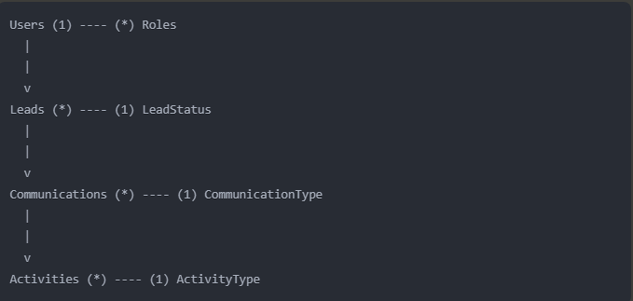

Figure 2.8 ER Diagram for CRM System

Key entities:

* Users: Store user information
* Roles: Define permissions for role-based access control
* Leads: Store lead information
* LeadStatus: Define possible lead statuses
* Communications: Track all communications with leads
* CommunicationType: Define types of communications (email, SMS)
* Activities: Track user activities for audit purposes

ActivityType: Define types of activities

**2.2. Schema Design**

The database schema will use a hybrid approach:

* Relational Database (PostgreSQL): For core entities with well-defined relationships (Users, Roles, Lead metadata)
* Document Database (MongoDB): For flexible data like custom fields, lead details, and communication content
* Time-Series Database: For activity logs and performance metrics

Schema considerations:

* GDPR compliance will be built into the schema design with fields for consent tracking, data retention policies, and data subject access requests
* Encryption will be applied to personally identifiable information (PII)
* Indexing strategies will optimize for common query patterns

**3. Data Exchange Contract:**

**3.1. Frequency of data exchanges**

* Real-time exchanges:
  + User authentication/authorization
  + Lead status updates
  + Incoming communications
  + Activity logging
* Batch exchanges:
  + Report generation (hourly/daily)
  + Lead scoring updates (hourly)
  + Bulk data imports/exports (as needed)
  + Analytics processing (daily)

**3.2. Data Sets**

Core data sets exchanged between services:

1. User data:
   * Profile information
   * Authentication credentials
   * Role assignments
   * Preferences
2. Lead data:
   * Contact information
   * Company details
   * Interaction history
   * Custom fields
   * Lead scores
   * Status information
3. Communication data:
   * Email content
   * SMS content
   * Communication metadata
   * Delivery status
4. Activity data:
   * User actions
   * System events
   * Timestamps
   * Contextual information
5. Configuration data:
   * System settings
   * Workflow definitions
   * Report templates

**3.3. Mode of Exchanges (API, File, Queue etc.)**

1. REST APIs:
   * Primary method for synchronous service-to-service communication
   * All client-to-server communication
   * External system integration
   * Mobile app communication
2. Message Queues (RabbitMQ/Kafka):
   * Event distribution
   * Asynchronous processing
   * Reliable delivery of critical updates
3. GraphQL API:
   * For complex data queries
   * Customizable reports
   * Frontend data fetching with specific field requirements
4. Webhook callbacks:
   * Integration with external email/SMS providers
   * Notification of external systems
5. Batch Files:
   * Bulk data import/export
   * Report exports

**2.1.4 Diagrams**

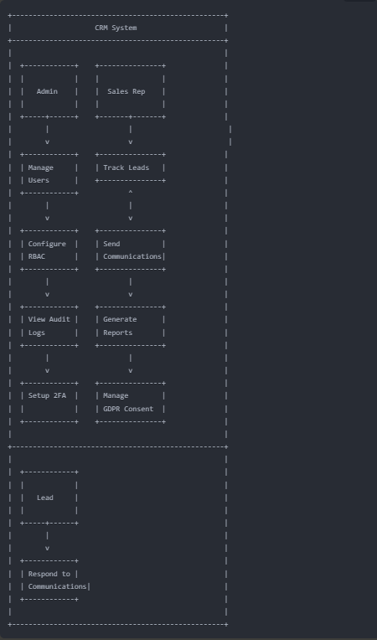

Figure 2.5 Use Case Diagram

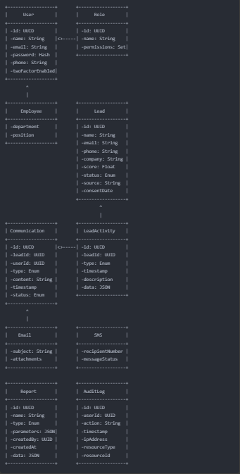

Figure 2.6 Class Diagram

**UI Design**

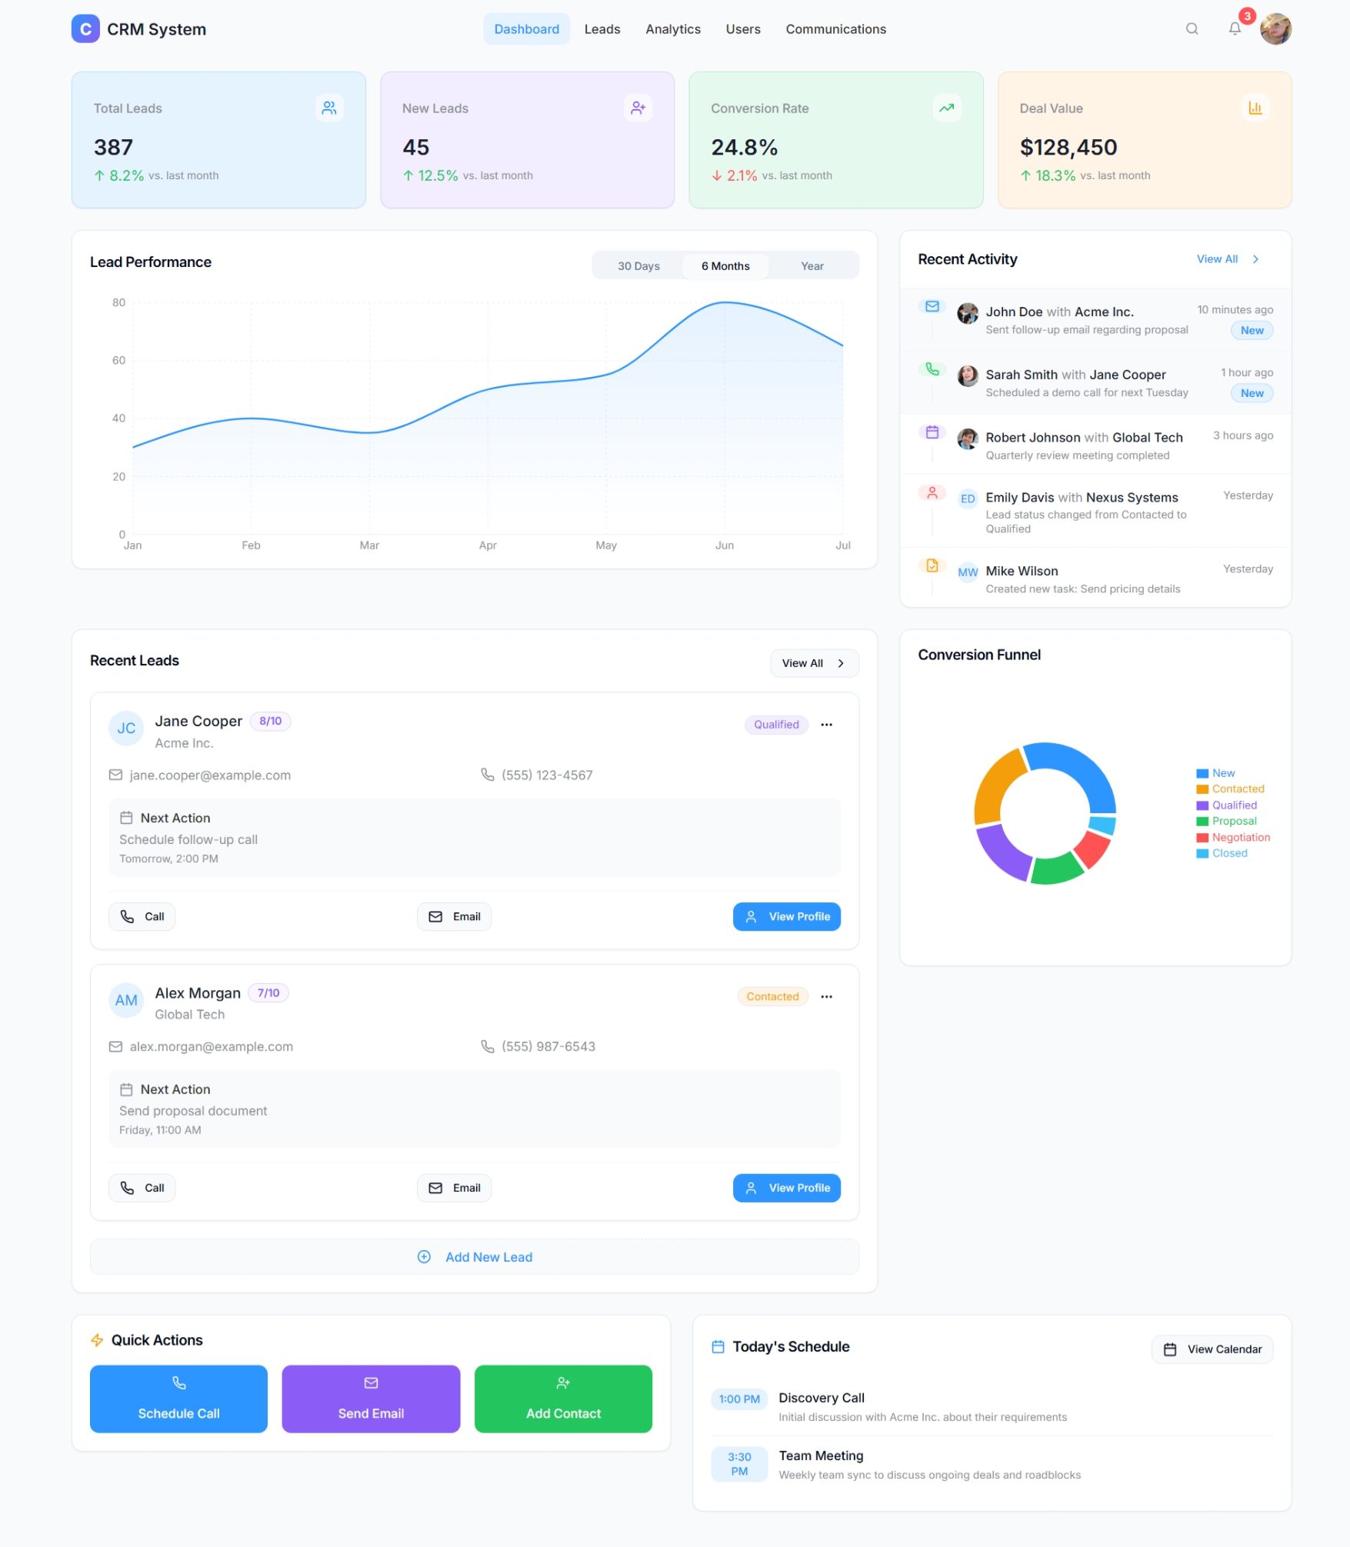

Figure 2.6 UI Design of dashboard page

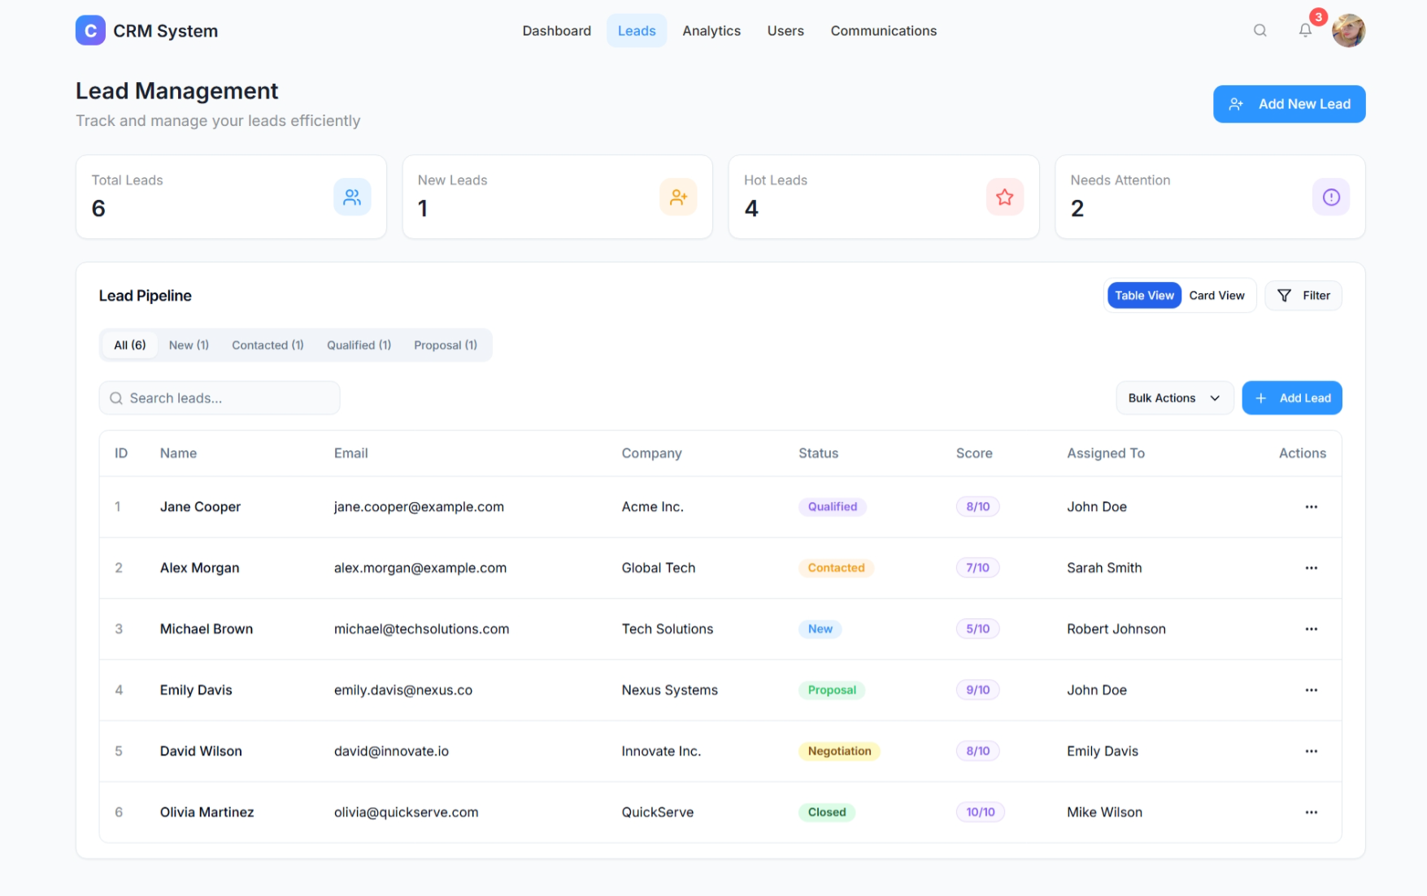

Figure 2.6 UI Design of leads page

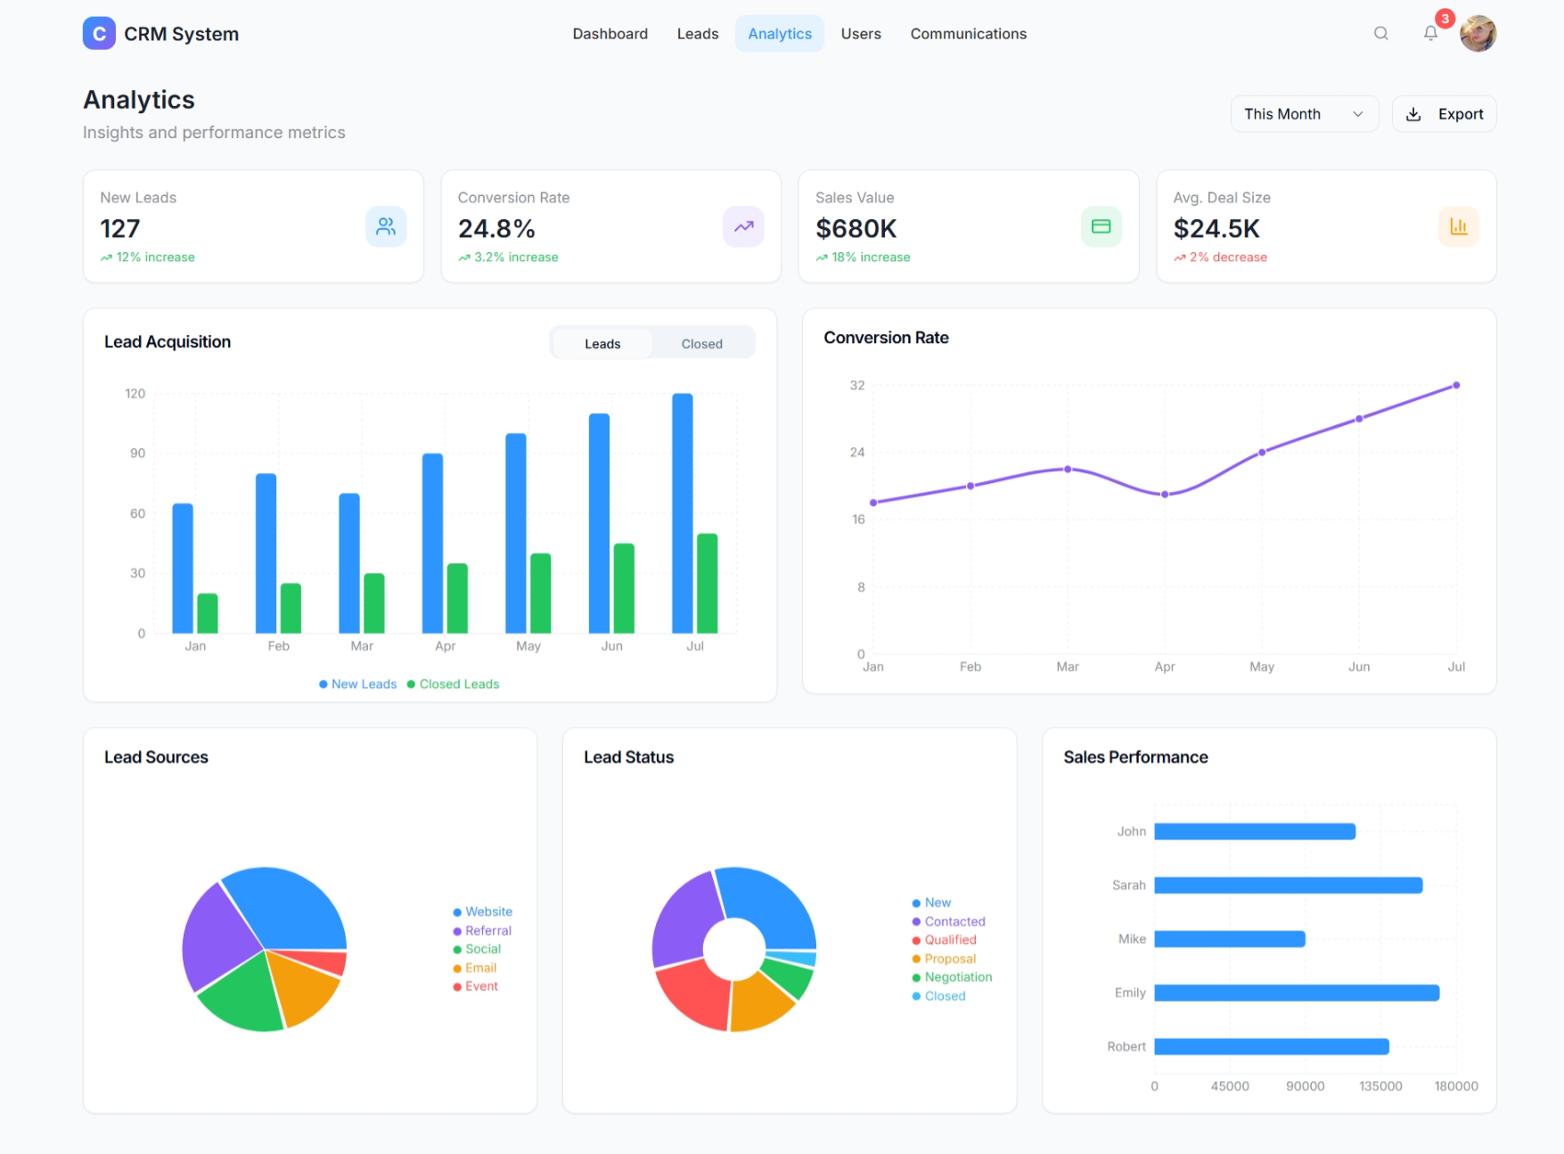

Figure 2.6 UI Design of analytics page

**2.1.5 Functional Test Cases**

Table 2.3 Detailed Functional Test Case sprint 1

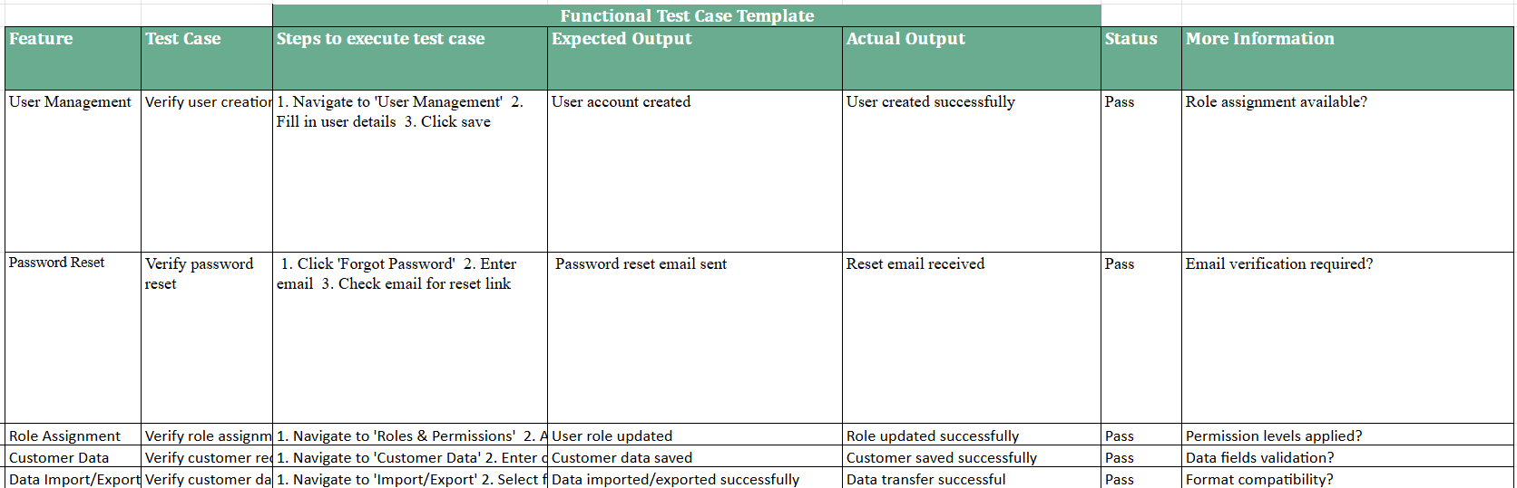

**2.1.6 Daily Call Progress**

| **Day** | **Tasks Completed** | **Ongoing Tasks** | **Blockers (If Any)** |
| --- | --- | --- | --- |
| Day 1 | Sprint kickoff, sprint planning, backlog review | Environment setup | None |
| Day 2 | Basic UI for user registration and login created | Backend integration for authentication | None |
| Day 3 | Contact management UI designed | Profile linking and form validation | Awaiting finalized data schema |
| Day 4 | Role-based access logic developed | Testing user permissions | Minor bugs in access validation |
| Day 5 | Lead tracking module backend implemented | UI adjustments and API connections | Delay in API endpoint testing |
| Day 6 | Customer history view completed | Dashboard structure under review | None |
| Day 7 | Unit testing of core modules done | Sprint demo preparation and documentation | None |

**2.1.7 Committed Vs Completed User Stories**

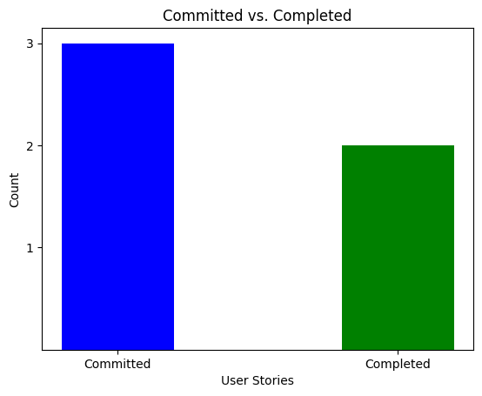

Figure 2.8 Bar graph for Committed Vs Completed User Stories sprint 1

**2.1.8 Sprint Retrospective**

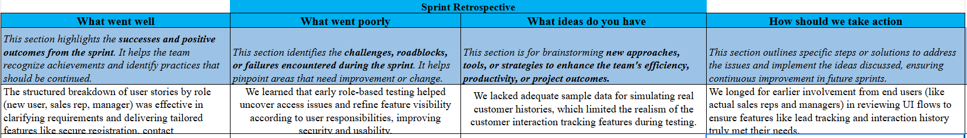

Figure 2.9 Sprint Retrospective for the Sprint 1

**2.2 SPRINT 2**

**2.2.1 Sprint Goal with User Stories of Sprint 2**

The objective of Sprint 2 is to extend the CRM system's core functionalities by enhancing data visualization, multi-channel communication, third-party integrations, and mobile accessibility, while ensuring robust user access control. This sprint focuses on providing managers with interactive dashboards and performance reports (#US 7) to support strategic decision-making. It also enables users to interact with customers directly through integrated channels like email, chat, and phone within the platform (#US 8), improving responsiveness and engagement.

By completing this sprint, the platform will evolve into a more collaborative, secure, and accessible solution, meeting the real-time needs of users across roles and devices.

The following table 2.1 represents the detailed user stories of the sprint 1

**Table 2.1 Detailed User Stories of sprint 2**

| **S.NO** | **Detailed User Stories** |
| --- | --- |
| #US 7 | As a manager, I want access to visual dashboards and reports so I can analyze sales performance and customer engagement. |
| #US 8 | As a user, I want to communicate with customers via email, chat, or phone within the platform for seamless interaction. |
| #US 9 | As a user, I want to integrate CRM data with third-party tools like Google Calendar and email for smoother workflow. |
| #US 10 | As an admin, I want to set user permissions and access levels so I can ensure security and control over data. |
| #US 11 | As a user, I want to access the CRM on mobile devices so I can manage leads and tasks on the go. |

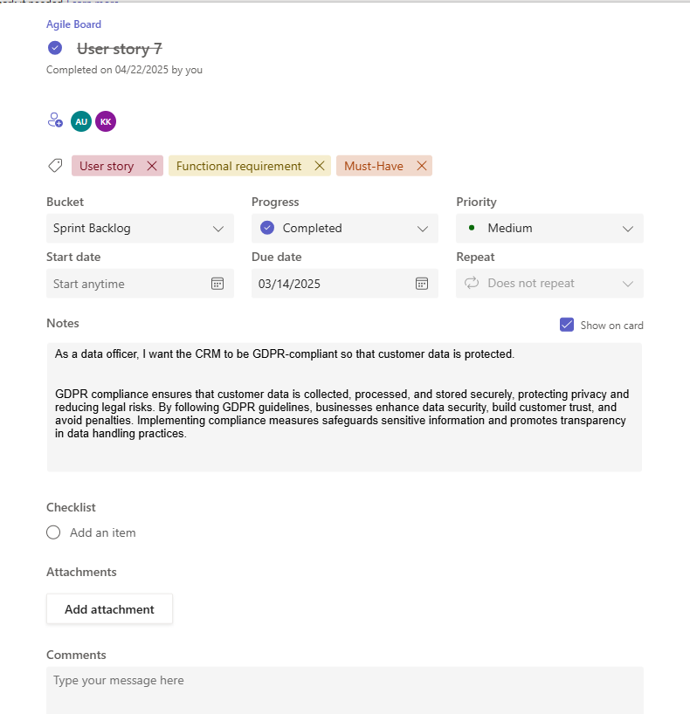

Figure 2.3 User story for lead tracking

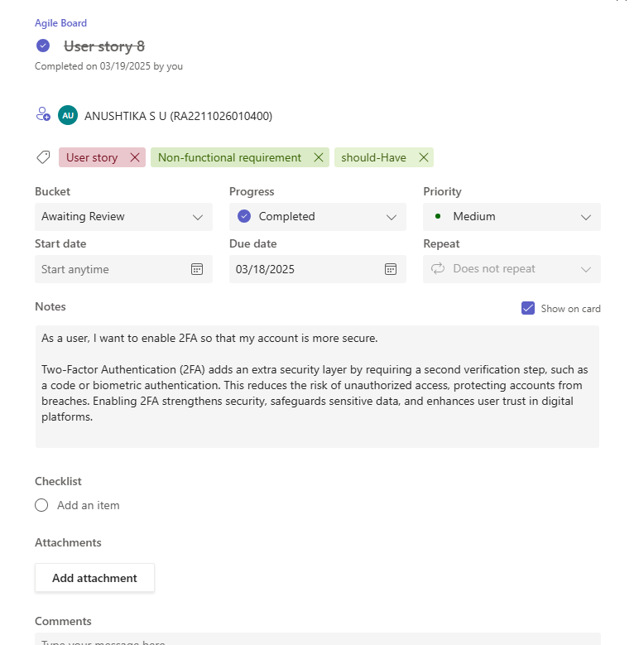

Figure 2.3 User story for lead tracking

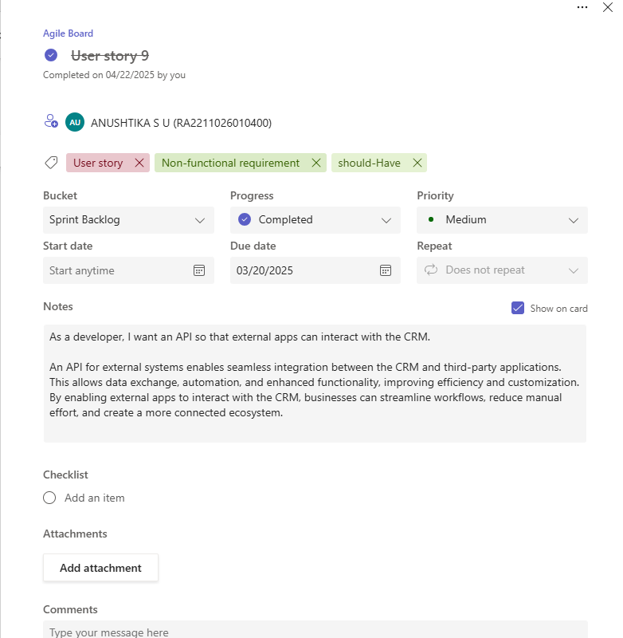

Figure 2.3 User story for lead tracking

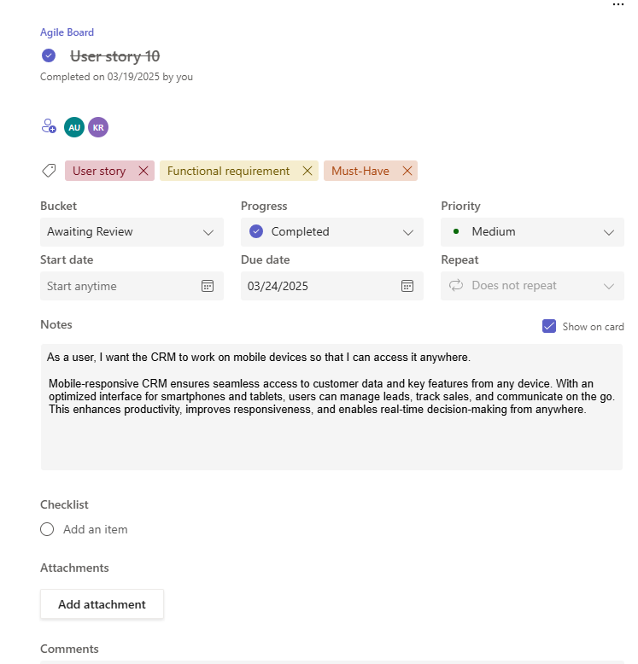

Figure 2.3 User story for lead tracking

**2.2.2 Functional Document**

### **Feature 7: Visual Dashboards and Reports**

Description:  
 An analytics module that provides interactive visual dashboards and reports with sales metrics, lead progress, and customer engagement trends. Includes customizable KPIs, filters, and export options to support strategic decision-making.  
User Story:  
 As a manager, I want access to visual dashboards and reports so I can analyze sales performance and customer engagement.

### **Feature 8: Multi-Channel Communication**

Description:  
 A built-in communication system allowing users to connect with customers via email, live chat, and call integration from within the CRM. Ensures seamless tracking and logging of all customer interactions in one place.  
 User Story:  
 As a user, I want to communicate with customers via email, chat, or phone within the platform for seamless interaction.

### **Feature 9: Third-Party Integration Support**

Description:  
 Support for integrating CRM data with third-party tools like Google Calendar, Gmail, and other productivity platforms. Enhances workflow automation and provides unified access to external tools for scheduling and communication.  
 User Story:  
 As a user, I want to integrate CRM data with third-party tools like Google Calendar and email for smoother workflow.

### **Feature 10: User Role and Access Management**

Description:  
 A role-based access control system that allows administrators to define user roles, set permission levels, and restrict data access based on responsibilities. Ensures platform security and controlled data visibility.  
 User Story:  
 As an admin, I want to set user permissions and access levels so I can ensure security and control over data.

### **Feature 11: Mobile CRM Access**

Description:  
 A responsive mobile interface or dedicated app that provides full access to CRM features like task management, lead updates, and communication tools, ensuring productivity while on the move.  
 User Story:  
 As a user, I want to access the CRM on mobile devices so I can manage leads and tasks on the go.

**2.2.2.6. Authorization Matrix**

The CRM system will have role-based access control to ensure data security and privacy:

**Table 2.6 Access level Authorization Matrix for sprint 2**

| **Role** | **Access Level** |
| --- | --- |
| Admin | Full access to dashboards, communication modules, integration settings, and role-based access control. |
| Sales Representative | Access to personal dashboards, lead and task management, communication tools, and calendar integration. |
| Customer Support | Access to communication tools for customer interaction and limited access to mobile CRM features. |
| Marketing Manager | Access to campaign reports, integration visibility, and communication analytics. |
| Manager/Executive | Access to full dashboards, team performance metrics, reports, and mobile features. |

**2.1.2.7. Assumptions**

* Dashboards and reporting modules will be powered by real-time data from the CRM database and use standard visualization libraries (e.g., Chart.js or Power BI).
* Communication channels (email, chat, phone) are assumed to be integrated using secure and scalable third-party APIs like SendGrid, Twilio, or similar.
* Calendar and email integrations (e.g., Google Calendar, Outlook) require users to authenticate using OAuth 2.0 for access to external data.
* Role-based access control (RBAC) will be implemented via an admin dashboard and assumes roles are predefined during system setup.
* Mobile access assumes the CRM uses responsive design or a PWA (Progressive Web App) and users will have stable internet connectivity.
* All users accessing sensitive data or communication logs must be authenticated, and data access is governed by permissions set by the admin.

**2.2.3 Architecture Document**

* User Authentication & Role-Based Access Control (RBAC) secures login, registration, and role-specific access to features.
* Lead and Customer Management adds, update, assign, and track leads and customer interactions.
* Email Campaign Scheduling & Automation creates, schedule, and automate marketing campaigns via third-party services.
* Real-Time Notifications & Alerts notify users of lead activity, task updates, and campaign status in real time.
* Dashboards and Reporting display real-time analytics, performance metrics, and KPIs using integrated visualization tools.



Figure 2.1 CRM System Architecture

### **2.2.4 Data Exchange Contract (Sprint 2)**

### **Frequency of Data Exchanges**

Real-time exchanges:

* Dashboard metrics updates (US 7)
* Customer communications (US 8)
* Calendar/email sync actions (US 9)
* User permission checks and role assignments (US 10)
* Mobile activity syncing (US 11)

Batch exchanges:

* Sales performance reports (hourly/daily)
* Campaign engagement analytics (daily)
* CRM-mobile data sync (daily backup)
* User activity and audit logs (nightly)

### **2.2.4.1 Data Sets**

Dashboard Data (US 7):

* Sales KPIs (revenue, conversion rate, active leads)
* Engagement metrics
* Filter parameters (date ranges, team performance)
* Visualization schema (chart types, axes, values)

Communication Data (US 8):

* Message content (email, chat, phone logs)
* Sender/recipient identifiers
* Timestamps
* Delivery and response status
* Channel metadata

Integration Data (US 9):

* OAuth tokens for Google APIs
* Calendar events
* Email configuration settings
* Sync status and error logs

User Management Data (US 10):

* User ID and profile
* Assigned roles (admin, manager, rep, marketer)
* Access levels to modules/features
* Permissions audit logs

Mobile CRM Data (US 11):

* Assigned tasks and lead info
* Real-time notifications
* Mobile-friendly UI data payloads
* User preferences and caching behavior

### **2.2.4.2 Mode of Exchanges**

REST APIs:

* All module interactions (dashboard, communication, permissions)
* Third-party integration calls
* Mobile client-server sync

Message Queues (e.g., RabbitMQ/Kafka):

* Background sync of calendar/email data
* Delayed task/event notifications
* Resilient communication pipeline for real-time alerts

GraphQL APIs:

* Customized dashboard views
* On-demand report data querying
* Mobile field-level data requests

Webhook Callbacks:

* Email/SMS delivery tracking from providers
* External integration status updates (Google, calendar, etc.)

Batch Files:

* Campaign reports export
* Mobile data backup
* Admin-level system configuration dumps

**2.2.4 UI Design**

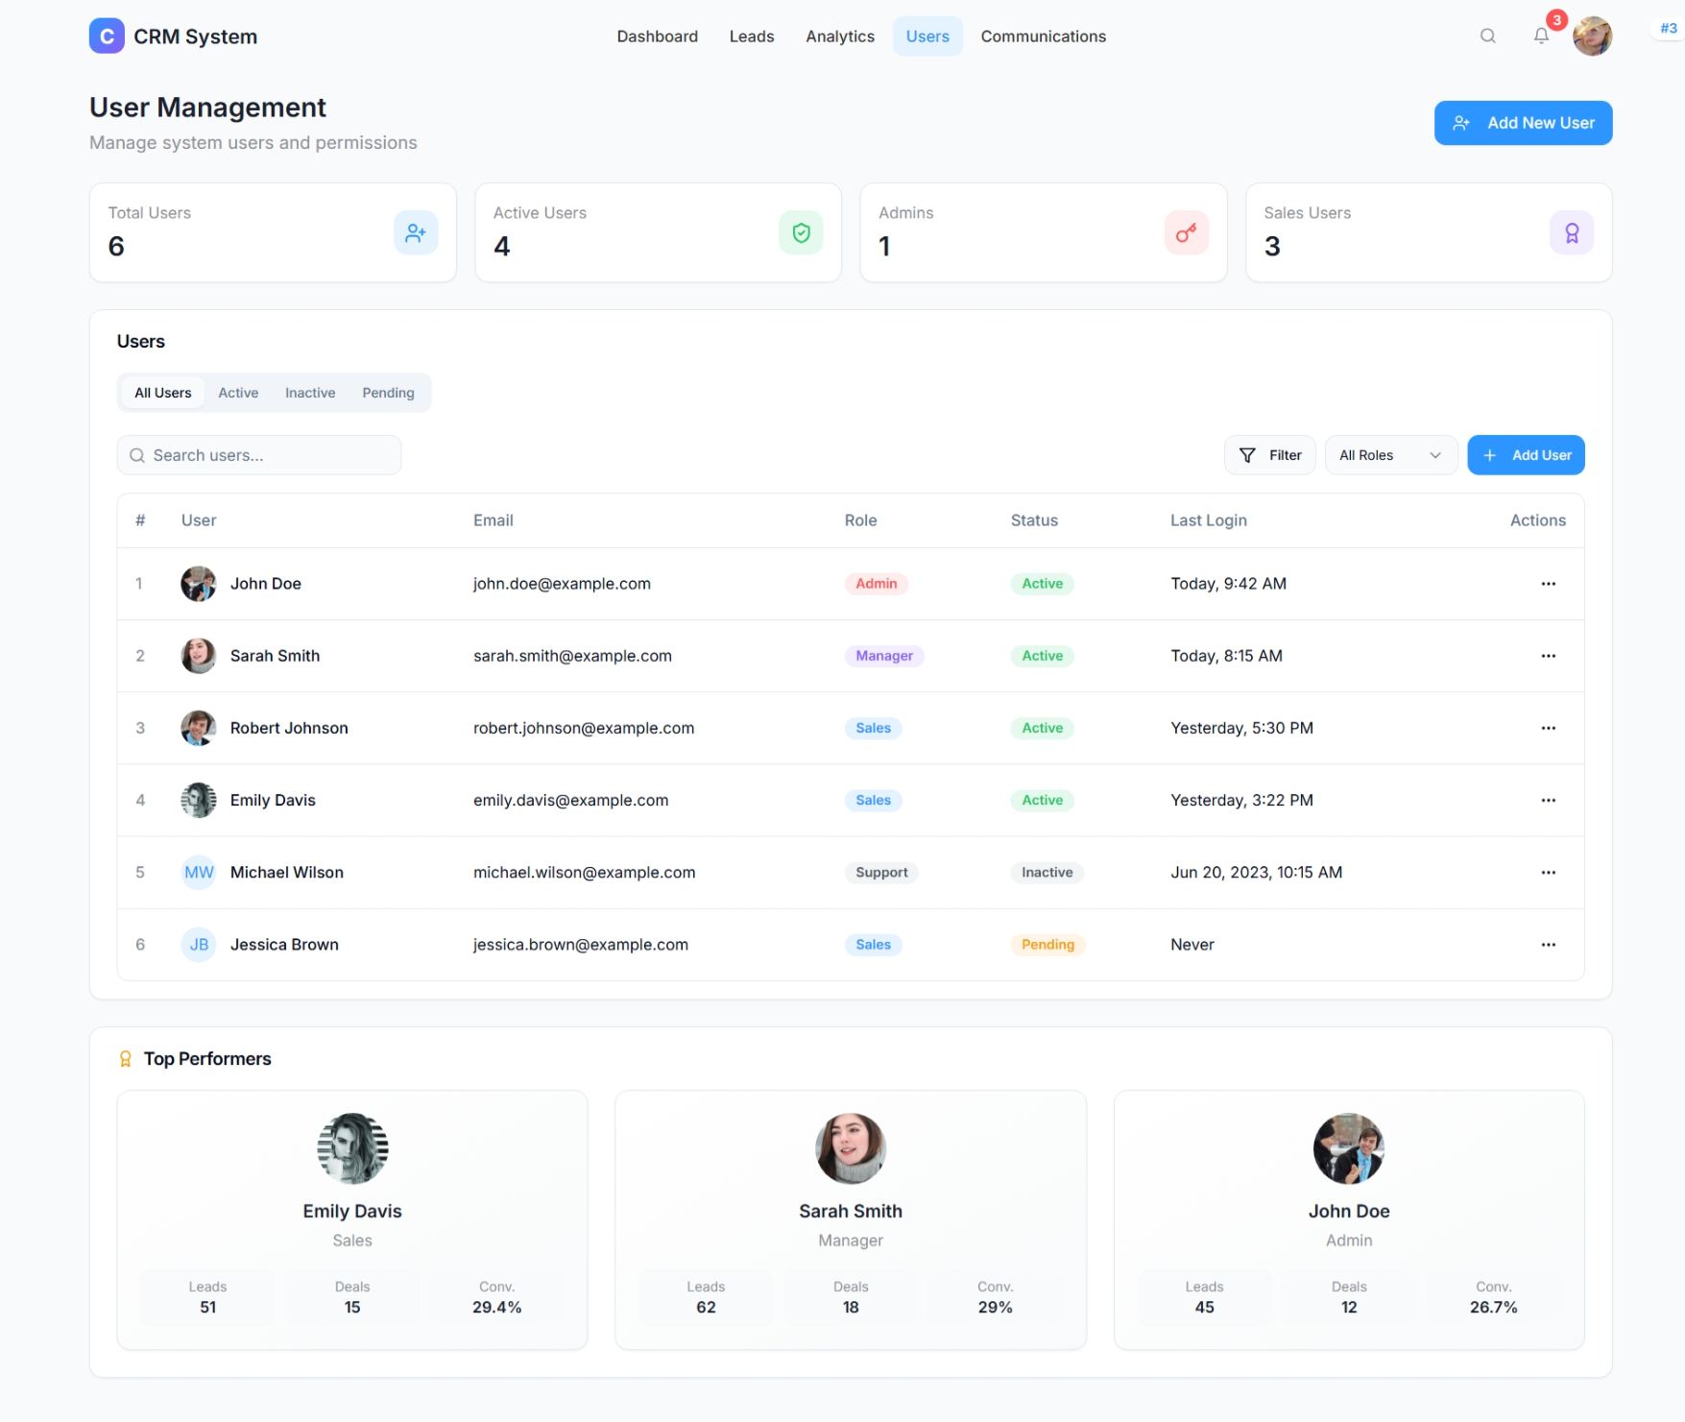

Figure 2.3 UI Design for Users

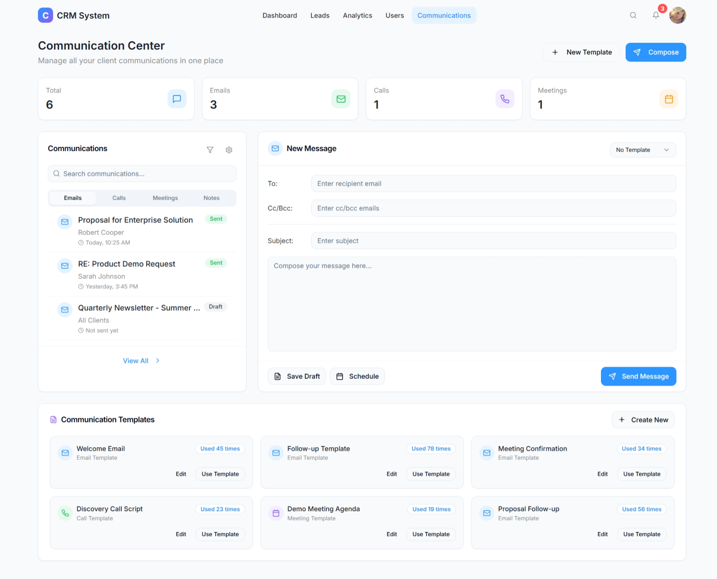

Figure 2.3 UI Design for Communications

**2.2.5 Functional Test Cases**

Table 2.3 Detailed Functional Test Case sprint 2

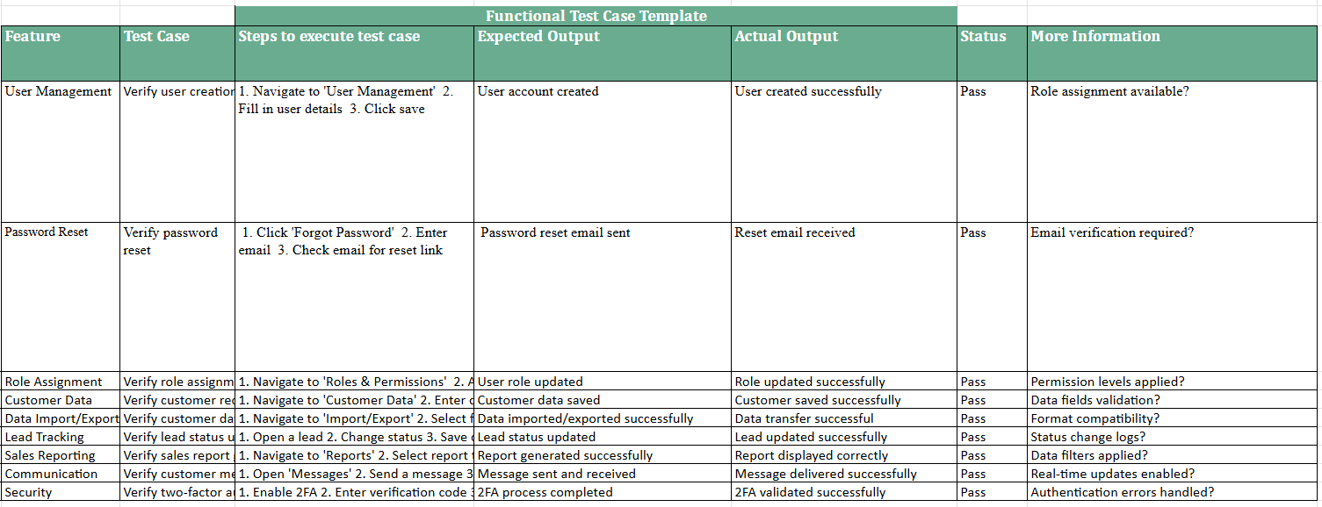

**2.2.6 Daily Call Progress**

| **Day** | **Tasks Completed** | **Ongoing Tasks** | **Blockers (If Any)** |
| --- | --- | --- | --- |
| Day 1 | Sprint 2 kickoff, story breakdown, environment config for dashboard | Initial dashboard wireframing | None |
| Day 2 | Communication module UI draft (US 8), dashboard metric list finalized | Backend setup for communication tools | None |
| Day 3 | Google API research & OAuth setup (US 9), dashboard skeleton developed | Calendar sync implementation | API rate limit issues |
| Day 4 | User permissions logic initialized (US 10), calendar integration tested | Admin panel UI for permissions | Role mapping issues |
| Day 5 | Mobile UI prototype created (US 11), email/chat flow tested | Mobile task flow and dashboard testing | Device responsiveness inconsistencies |
| Day 6 | Reporting module connected to sample data, user roles refined | UI optimization and mobile responsiveness | Data visualization lag on mobile |
| Day 7 | Final integration review, bug fixes across modules | Sprint demo prep and documentation | None |

**2.2.7 COMMITTED Vs COMPLETED USER STORIES**

Figure 2.22 Committed Vs Completed User Stories sprint 2

**2.2.8 Sprint Retrospective**

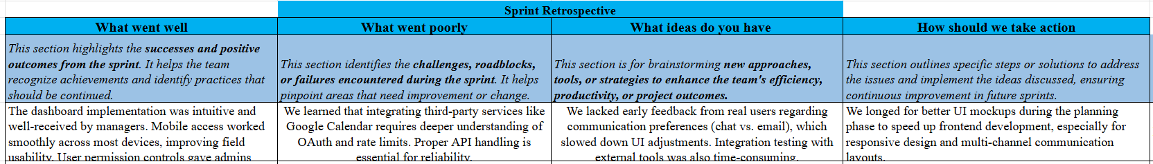

Figure 2.9 Sprint Retrospective for the Sprint 2

**CHAPTER 3**

**RESULTS AND DISCUSSION**

**3.1 Project Outcomes:**

The Customer Relationship Management (CRM) system developed over the course of multiple sprints delivered a robust, scalable, and user-centric platform designed to improve customer engagement, streamline business operations, and support data-driven decision-making.

**Core Features Delivered:** The project successfully implemented all planned features including user registration, lead management, visual dashboards, communication modules (email/chat/phone), third-party integrations, and mobile accessibility. These features align with the core objectives of enhancing customer interaction, improving internal workflows, and providing real-time access to data.  
**User Experience Improvements:** Personalized dashboards and a responsive interface ensured that users—from sales reps to managers—had intuitive access to features based on their roles. Mobile accessibility greatly improved field operations for sales and support teams.  
**Performance and Scalability:** The microservices-based architecture allowed services like email automation, analytics, and communication to scale independently. Event-driven components provided real-time notifications and improved responsiveness.  
**Security and Role-Based Access:** Admins could define granular permissions using a secure role-based access control model, safeguarding sensitive customer and business data.  
**Third-Party Integration:** Successful integration with tools like Google Calendar and email platforms enhanced workflow continuity, allowing users to sync meetings, tasks, and customer communications across systems.

#### **Key Achievements**

* Automation of lead tracking and communication tasks led to faster response times and higher conversion rates.
* Real-time dashboards improved management oversight and sales pipeline visibility.
* The communication suite enabled seamless interaction without switching between platforms.
* Role-based access and GDPR-compliant data handling increased trust and regulatory alignment.

#### **3.3 Challenges Faced**

* Initial third-party API integrations caused delays due to authentication and rate-limit complexities.
* Device-specific UI bugs on mobile platforms required extended QA cycles.
* Aligning communication workflows with user expectations demanded frequent UI/UX adjustments.

#### **3.4 Lessons Learned**

* Involving end-users (sales, marketing, support) early in UI testing helps uncover usability issues before deployment.
* Modular, microservices architecture reduces interdependency bottlenecks and simplifies feature updates.
* Real-time event handling adds value but demands careful design around system consistency and fail-safes.

**3.2 Committed Vs Completed User stories**

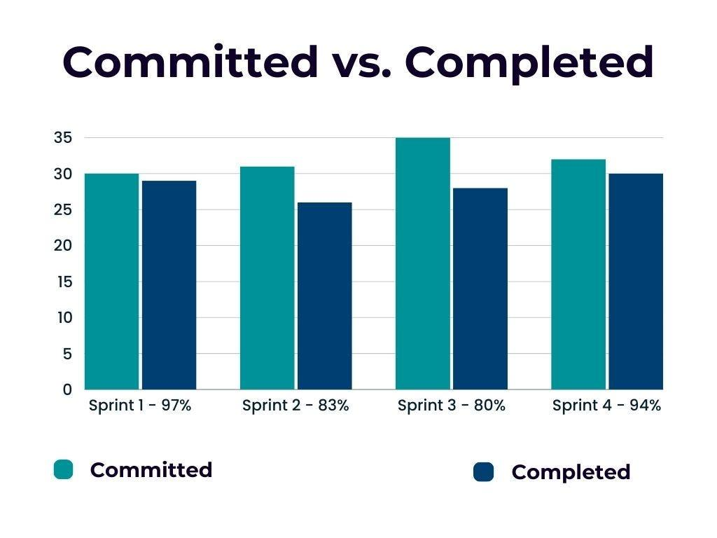

Figure 2.22 Committed Vs Completed User Stories

**CHAPTER 4**

**CONCLUSION & FUTURE ENHANCEMENTS**

#### **4.1 Conclusion**

The development and deployment of the Customer Relationship Management (CRM) system marked a significant step toward improving customer engagement, operational efficiency, and data-driven decision-making within the organization. By leveraging modern architectural patterns such as microservices and event-driven processing, the project delivered a modular, scalable, and responsive platform tailored to the distinct needs of sales, marketing, and support teams.

Key functionalities like lead management, user-role authorization, real-time notifications, third-party integrations, and multi-channel communication were successfully implemented and tested across both desktop and mobile interfaces. Overall, the CRM system has enhanced the company’s ability to centralize customer data, automate outreach, and monitor performance through intuitive dashboards and reports.

#### **4.2 Future Enhancements**

To ensure continuous improvement and long-term adaptability, the following enhancements are proposed for future development cycles:

1. AI-Powered Lead Scoring:  
    Introduce machine learning algorithms to score and prioritize leads based on behavioral data and historical conversions.
2. Chatbot Integration:  
    Implement AI-based chatbots for 24/7 customer support and lead qualification, reducing manual workload for support staff.
3. Advanced Reporting Engine:  
    Provide more customizable report templates and support for predictive analytics to forecast trends and customer behavior.
4. Offline Access Mode:  
    Enable core CRM features to be available offline on mobile devices, with data syncing once connectivity is restored.
5. Multi-language and Localization Support:  
    Expand usability to international teams by supporting multiple languages and regional date/time/formatting standards.
6. Gamification for Sales Teams:  
    Integrate gamified elements like leaderboards, badges, and rewards to motivate and track sales team performance.
7. Customer Feedback & NPS Module:  
    Add a feature for collecting customer feedback, reviews, and Net Promoter Score (NPS) to assess satisfaction and loyalty.

**APPENDIX**

* 1. **SAMPLE CODING**

{

"$schema": "https://ui.shadcn.com/schema.json",

"style": "default",

"rsc": false,

"tsx": true,

"tailwind": {

"config": "tailwind.config.ts",

"css": "src/index.css",

"baseColor": "slate",

"cssVariables": true,

"prefix": ""

},

"aliases": {

"components": "@/components",

"utils": "@/lib/utils",

"ui": "@/components/ui",

"lib": "@/lib",

"hooks": "@/hooks"

}

}

import js from "@eslint/js";

import globals from "globals";

import reactHooks from "eslint-plugin-react-hooks";

import reactRefresh from "eslint-plugin-react-refresh";

import tseslint from "typescript-eslint";

export default tseslint.config(

{ ignores: ["dist"] },

{

extends: [js.configs.recommended, ...tseslint.configs.recommended],

files: ["**/*.{ts,tsx}"],

languageOptions: {

ecmaVersion: 2020,

globals: globals.browser,

},

plugins: {

"react-hooks": reactHooks,

"react-refresh": reactRefresh,

},

rules: {

...reactHooks.configs.recommended.rules,

"react-refresh/only-export-components": [

"warn",

{ allowConstantExport: true },

],

"@typescript-eslint/no-unused-vars": "off",

},

}

);

<!DOCTYPE html>

<html lang="en">

<head>

<meta charset="UTF-8" />

<meta name="viewport" content="width=device-width, initial-scale=1.0" />

<title>clever-contact-hub</title>

<meta name="description" content="Lovable Generated Project" />

<meta name="author" content="Lovable" />

<meta property="og:image" content="/og-image.png" />

</head>

<body>

<div id="root"></div>

<!-- IMPORTANT: DO NOT REMOVE THIS SCRIPT TAG OR THIS VERY COMMENT! -->

<script src="https://cdn.gpteng.co/gptengineer.js" type="module"></script>

<script type="module" src="/src/main.tsx"></script>

</body>

</html>

{

"name": "vite_react_shadcn_ts",

"private": true,

"version": "0.0.0",

"type": "module",

"scripts": {

"dev": "vite",

"build": "vite build",

"build:dev": "vite build --mode development",

"lint": "eslint .",

"preview": "vite preview"

},

"dependencies": {

"@hookform/resolvers": "^3.9.0",

"@radix-ui/react-accordion": "^1.2.0",

"@radix-ui/react-alert-dialog": "^1.1.1",

"@radix-ui/react-aspect-ratio": "^1.1.0",

"@radix-ui/react-avatar": "^1.1.0",

"@radix-ui/react-checkbox": "^1.1.1",

"@radix-ui/react-collapsible": "^1.1.0",

"@radix-ui/react-context-menu": "^2.2.1",

"@radix-ui/react-dialog": "^1.1.2",

"@radix-ui/react-dropdown-menu": "^2.1.1",

"@radix-ui/react-hover-card": "^1.1.1",

"@radix-ui/react-label": "^2.1.0",

"@radix-ui/react-menubar": "^1.1.1",

"@radix-ui/react-navigation-menu": "^1.2.0",

"@radix-ui/react-popover": "^1.1.1",

"@radix-ui/react-progress": "^1.1.0",

"@radix-ui/react-radio-group": "^1.2.0",

"@radix-ui/react-scroll-area": "^1.1.0",

"@radix-ui/react-select": "^2.1.1",

"@radix-ui/react-separator": "^1.1.0",

"@radix-ui/react-slider": "^1.2.0",

"@radix-ui/react-slot": "^1.1.0",

"@radix-ui/react-switch": "^1.1.0",

"@radix-ui/react-tabs": "^1.1.0",

"@radix-ui/react-toast": "^1.2.1",

"@radix-ui/react-toggle": "^1.1.0",

"@radix-ui/react-toggle-group": "^1.1.0",

"@radix-ui/react-tooltip": "^1.1.4",

"@tanstack/react-query": "^5.56.2",

"class-variance-authority": "^0.7.1",

"clsx": "^2.1.1",

"cmdk": "^1.0.0",

"date-fns": "^3.6.0",

"embla-carousel-react": "^8.3.0",

"framer-motion": "^12.5.0",

"input-otp": "^1.2.4",

"lucide-react": "^0.462.0",

"next-themes": "^0.3.0",

"react": "^18.3.1",

"react-day-picker": "^8.10.1",

"react-dom": "^18.3.1",

"react-hook-form": "^7.53.0",

"react-resizable-panels": "^2.1.3",

"react-router-dom": "^6.26.2",

"recharts": "^2.12.7",

"sonner": "^1.5.0",

"tailwind-merge": "^2.5.2",

"tailwindcss-animate": "^1.0.7",

"vaul": "^0.9.3",

"zod": "^3.23.8"

},

"devDependencies": {

"@eslint/js": "^9.9.0",

"@tailwindcss/typography": "^0.5.15",

"@types/node": "^22.5.5",

"@types/react": "^18.3.3",

"@types/react-dom": "^18.3.0",

"@vitejs/plugin-react-swc": "^3.5.0",

"autoprefixer": "^10.4.20",

"eslint": "^9.9.0",

"eslint-plugin-react-hooks": "^5.1.0-rc.0",

"eslint-plugin-react-refresh": "^0.4.9",

"globals": "^15.9.0",

"lovable-tagger": "^1.1.7",

"postcss": "^8.4.47",

"tailwindcss": "^3.4.11",

"typescript": "^5.5.3",

"typescript-eslint": "^8.0.1",

"vite": "^5.4.1"

}

}

export default {

plugins: {

tailwindcss: {},

autoprefixer: {},

},

}

import type { Config } from "tailwindcss";

export default {

darkMode: ["class"],

content: [

"./pages/**/*.{ts,tsx}",

"./components/**/*.{ts,tsx}",

"./app/**/*.{ts,tsx}",

"./src/**/*.{ts,tsx}",

],

prefix: "",

theme: {

container: {

center: true,

padding: '2rem',

screens: {

'2xl': '1400px'

}

},

extend: {

colors: {

border: 'hsl(var(--border))',

input: 'hsl(var(--input))',

ring: 'hsl(var(--ring))',

background: 'hsl(var(--background))',

foreground: 'hsl(var(--foreground))',

primary: {

DEFAULT: 'hsl(var(--primary))',

foreground: 'hsl(var(--primary-foreground))'

},

secondary: {

DEFAULT: 'hsl(var(--secondary))',

foreground: 'hsl(var(--secondary-foreground))'

},

destructive: {

DEFAULT: 'hsl(var(--destructive))',

foreground: 'hsl(var(--destructive-foreground))'

},

muted: {

DEFAULT: 'hsl(var(--muted))',

foreground: 'hsl(var(--muted-foreground))'

},

accent: {

DEFAULT: 'hsl(var(--accent))',

foreground: 'hsl(var(--accent-foreground))'

},

popover: {

DEFAULT: 'hsl(var(--popover))',

foreground: 'hsl(var(--popover-foreground))'

},

card: {

DEFAULT: 'hsl(var(--card))',

foreground: 'hsl(var(--card-foreground))'

},

sidebar: {

DEFAULT: 'hsl(var(--sidebar-background))',

foreground: 'hsl(var(--sidebar-foreground))',

primary: 'hsl(var(--sidebar-primary))',

'primary-foreground': 'hsl(var(--sidebar-primary-foreground))',

accent: 'hsl(var(--sidebar-accent))',

'accent-foreground': 'hsl(var(--sidebar-accent-foreground))',

border: 'hsl(var(--sidebar-border))',

ring: 'hsl(var(--sidebar-ring))'

},

crm: {

'blue': '#2C95FF',

'light-blue': '#E5F2FF',

'purple': '#8B5CF6',

'light-purple': '#F3EEFF',

'green': '#22C55E',

'light-green': '#E6F9EE',

'red': '#FF5252',

'light-red': '#FFEDED',

'yellow': '#F59E0B',

'light-yellow': '#FFF4E6',

'gray': '#8E9196',

'light-gray': '#F1F2F6',

'dark-gray': '#333333',

'black': '#1A1F2C'

}

},

borderRadius: {

lg: 'var(--radius)',

md: 'calc(var(--radius) - 2px)',

sm: 'calc(var(--radius) - 4px)'

},

keyframes: {

'accordion-down': {

from: {

height: '0'

},

to: {

height: 'var(--radix-accordion-content-height)'

}

},

'accordion-up': {

from: {

height: 'var(--radix-accordion-content-height)'

},

to: {

height: '0'

}

},

'fade-in': {

'0%': { opacity: '0' },

'100%': { opacity: '1' }

},

'fade-out': {

'0%': { opacity: '1' },

'100%': { opacity: '0' }

},

'slide-up': {

'0%': { transform: 'translateY(20px)', opacity: '0' },

'100%': { transform: 'translateY(0)', opacity: '1' }

},

'slide-right': {

'0%': { transform: 'translateX(-20px)', opacity: '0' },

'100%': { transform: 'translateX(0)', opacity: '1' }

},

'scale-in': {

'0%': { transform: 'scale(0.95)', opacity: '0' },

'100%': { transform: 'scale(1)', opacity: '1' }

},

'float': {

'0%, 100%': { transform: 'translateY(0)' },

'50%': { transform: 'translateY(-5px)' }

},

'pulse-soft': {

'0%, 100%': { opacity: '1' },

'50%': { opacity: '0.8' }

}

},

animation: {

'accordion-down': 'accordion-down 0.2s ease-out',

'accordion-up': 'accordion-up 0.2s ease-out',

'fade-in': 'fade-in 0.3s ease-out',

'fade-out': 'fade-out 0.3s ease-out',

'slide-up': 'slide-up 0.4s ease-out',

'slide-right': 'slide-right 0.4s ease-out',

'scale-in': 'scale-in 0.3s ease-out',

'float': 'float 3s ease-in-out infinite',

'pulse-soft': 'pulse-soft 3s ease-in-out infinite'

},

backdropFilter: {

'none': 'none',

'blur': 'blur(20px)'

}

}

},

plugins: [require("tailwindcss-animate")],

} satisfies Config;

* 1. **PLAGIARISM REPORT**

